Below screenshot shows both ciphertext and decryption using a Caesar Cipher, this time using a keymap dictionary explicitly rather than basic math, adding randomness to the dictionary adds increased security to prevent the ability for another outside party to brute force decryption.

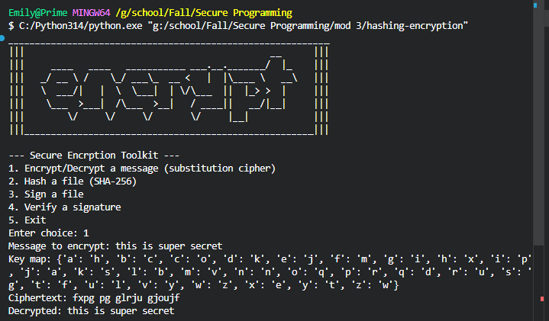

Below is an example of a sha256 encryption of a similar message string, the hash is significantly more secure than a basic cipher. Hashlib is backed by OpenSSL. Using a one way fingerprint to encode the message in a 256 bit output, even a single character change creates an completely different output while identical inputs, create identical outputs.
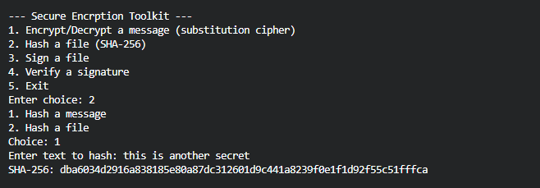
For hashing a file, the program is able to run a strip on the copied filepath once prompted through the menu.
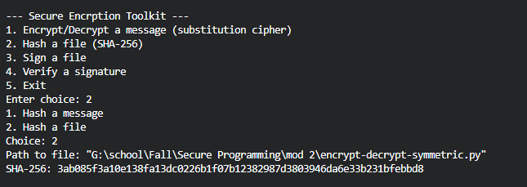

Using python’s cryptography library, we’re able to digitally sign using RSA public and private key pair generators. The signature proves that the file hasn’t been changed since the original signature, albeit, this programs signing system only works while the active session is running and has no persistence across multiple sessions.
verifying the signature works in the same way, the file is read again, and then the program compares that to the original signature. For a match, it outputs positive verification.

